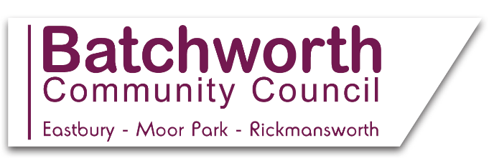

BATCHWORTH COMMUNITY COUNCIL
WORKING TO ENHANCE OUR COMMUNITY
LOCAL EASTBURY AND MOOR PARK NEWS MARCH 2021
*
The census is a once in a decade survey that provides the most accurate estimate of all the people and households in England and Wales. It’s been carried out every decade since 1801, with the exception of 1941. The information collected is used by local government to plan what services are needed in the future like housing, schools and doctors. Census Day is Sunday 21 March – but you can fill yours in online as soon as you get your access code in the post, which will arrive in early March. The census makes a difference to everyone. It’s a once in a decade chance to have your voice heard and help inform the future of your local area. Forms will be posted out to those residents automatically identified as elderly and vulnerable, but if you know someone who hasn’t received a form by post, or who needs help to complete it by phone, please telephone the ONS helpline on 01329 444972, Mon-Fri 9am-5pm.
*
Please take a minute to log onto the local Neighbourhood Plan website at https://batchworth.commonplace.is/ to comment on shaping the future of our local area. Please also sign up to be part of a local focus group to discuss this further, at https://www.batchworthplan.org.uk/focusandsteering-group/. If you have no access to the internet, or for more information, please ring 07939 986242.
*
All members of the public are very welcome to attend the Council’s Full Council, Planning and Finance Committee Meetings. Dates and agendas are listed on the Council’s website, with public participation sessions of 3 minutes per resident. Meetings are currently held remotely via Zoom, with log ins on the website. *
Basing House, 46 High Street, Rickmansworth, Herts WD3 1HP
Office Hours: Mons, Tues, Weds 9am-12 noon Drop in times: Mons 9am-12 noon
Clerk to the Council e mail: clerk@batchworth-ecc.gov.uk Tel: 01923 590201
Website: batchworth-ecc.gov.uk

