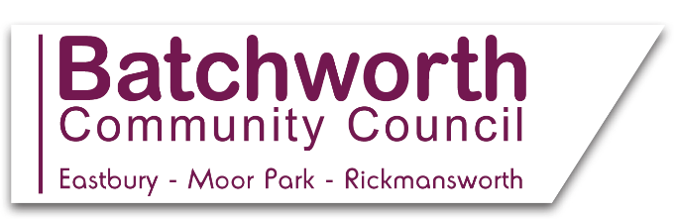

BATCHWORTH COMMUNITY COUNCIL
WORKING TO ENHANCE OUR COMMUNITY
LOCAL EASTBURY AND MOOR PARK NEWS JANUARY 2021
*
Batchworth Community Council have planted daffodil bulbs at the recreation ground to welcome in the Spring -watch that space!
*
Batchworth Community Council is a statutory consultee in the planning application review process. Planning committee meetings are held every two weeks, with an agenda showing the applications to be considered, plus the Zoom log in details, on the Community Council website. Whilst Batchworth Community Council has no power to approve or reject planning decisions, it submits comments to the district council, based on ‘material considerations’, namely valid reasons in law, for the district council to consider when they take decisions on the outcome of planning applications. Members of the public are very welcome to attend the planning meetings.
*
Please take a minute to log onto the local Neighbourhood Plan website at https://batchworth.commonplace.is/ to comment on shaping the future of our local area. Please also sign up to be part of a local focus group to discuss this further, at https://www.batchworthplan.org.uk/focusandsteering-group/. If you have no access to the internet, or for more information, please ring 07939 986242.
*
All members of the public are very welcome to attend the Council’s Full Council, Planning and Finance Committee Meetings. Dates and agendas are listed on the Council’s website, with public participation sessions of 3 minutes per resident. Meetings are currently held remotely via Zoom, with log ins on the website. *
The Councillors and Officers of Batchworth Community Council would like to take this opportunity to extend their best wishes to residents for 2021.
Basing House, 46 High Street, Rickmansworth, Herts WD3 1HP
Office Hours: Mons, Tues, Weds 9am-12 noon Drop in times: Mons 9am-12 noon
Clerk to the Council e mail: clerk@batchworth-ecc.gov.uk Tel: 01923 590201
Website: batchworth-ecc.gov.uk

