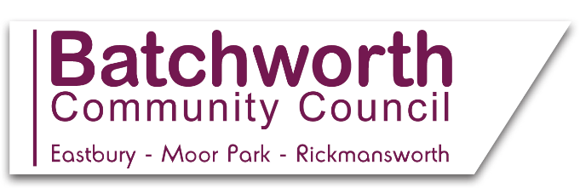

BATCHWORTH COMMUNITY COUNCIL
WORKING TO ENHANCE OUR COMMUNITY
LOCAL EASTBURY AND MOOR PARK NEWS FEBRUARY 2021
*
Batchworth Community Council have planted daffodil bulbs at the recreation ground to welcome in the Spring -watch that space!
*
The Council offers a grant awarding scheme to local groups, subject to consideration and subsequent approval at the Council’s Finance and Full Council Meetings. The maximum award is £500, unless an exceptional case can be made for more to be granted. Full details of the policy and the application form can be found on the Council’s website, details of which are found below.
*
Please take a minute to log onto the local Neighbourhood Plan website at https://batchworth.commonplace.is/ to comment on shaping the future of our local area. Please also sign up to be part of a local focus group to discuss this further, at https://www.batchworthplan.org.uk/focusandsteering-group/. If you have no access to the internet, or for more information, please ring 07939 986242.
*
All members of the public are very welcome to attend the Council’s Full Council, Planning and Finance Committee Meetings. Dates and agendas are listed on the Council’s website, with public participation sessions of 3 minutes per resident. Meetings are currently held remotely via Zoom, with log ins on the website. *
Basing House, 46 High Street, Rickmansworth, Herts WD3 1HP
Office Hours: Mons, Tues, Weds 9am-12 noon Drop in times: Mons 9am-12 noon
Clerk to the Council e mail: clerk@batchworth-ecc.gov.uk Tel: 01923 590201
Website: batchworth-ecc.gov.uk

